Database Management System components

🧱 What Are the Components of a Database Management System (DBMS)?
# Source: AI Source: Provided by: [Data Path: Persons Table -> ID Column: 1, Name_En Column: Motasem Essam] -> From: [ChatGPT] on [6/10/2026]
A Database Management System (DBMS) is made up of several core components that work together to store, retrieve, secure, and manage data effectively.

🧩 Main Components of a DBMS
# Source: AI Source: Provided by: [Data Path: Persons Table -> ID Column: 1, Name_En Column: Motasem Essam] -> From: [ChatGPT] on [6/10/2026]
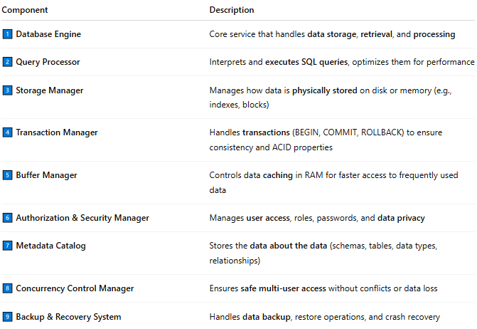
Component | Description
1️⃣ Database Engine | Core service that handles data storage, retrieval, and processing
2️⃣ Query Processor | Interprets and executes SQL queries, optimizes them for performance
3️⃣ Storage Manager | Manages how data is physically stored on disk or memory (e.g., indexes, blocks)
4️⃣ Transaction Manager | Handles transactions (BEGIN, COMMIT, ROLLBACK) to ensure consistency and ACID properties
5️⃣ Buffer Manager | Controls data caching in RAM for faster access to frequently used data
6️⃣ Authorization & Security Manager | Manages user access, roles, passwords, and data privacy
7️⃣ Metadata Catalog | Stores the data about the data (schemas, tables, data types, relationships)
8️⃣ Concurrency Control Manager | Ensures safe multi-user access without conflicts or data loss
9️⃣ Backup & Recovery System | Handles data backup, restore operations, and crash recovery

🔄 Diagram View (Simplified)
# Source: AI Source: Provided by: [Data Path: Persons Table -> ID Column: 1, Name_En Column: Motasem Essam] -> From: [ChatGPT] on [6/10/2026]
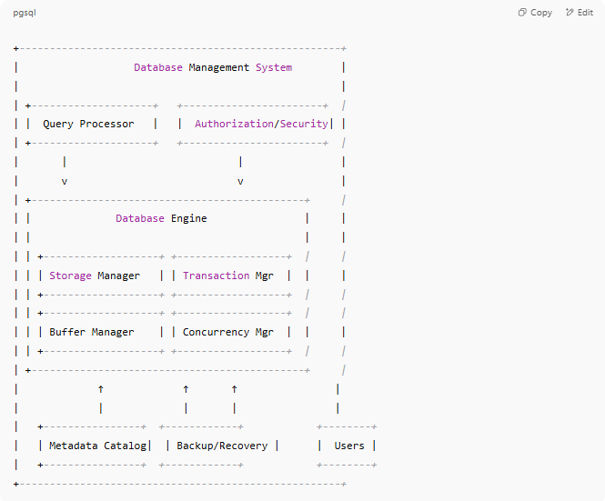
+-----------------------------------------------------+
| Database Management System |
| |
| +--------------------+ +-----------------------+ |
| | Query Processor | | Authorization/Security| |
| +--------------------+ +-----------------------+ |
| | | |
| v v |
| +---------------------------------------------+ |
| | Database Engine | |
| | | |
| | +-------------------+ +------------------+ | |
| | | Storage Manager | | Transaction Mgr | | |
| | +-------------------+ +------------------+ | |
| | +-------------------+ +------------------+ | |
| | | Buffer Manager | | Concurrency Mgr | | |
| | +-------------------+ +------------------+ | |
| +---------------------------------------------+ |
| ↑ ↑ ↑ |
| | | | |
| +----------------+ +------------+ +--------+
| | Metadata Catalog| | Backup/Recovery | | Users |
| +----------------+ +------------+ +--------+
+-----------------------------------------------------+

📘 Real-World Example (Using MySQL)
# Source: AI Source: Provided by: [Data Path: Persons Table -> ID Column: 1, Name_En Column: Motasem Essam] -> From: [ChatGPT] on [6/10/2026]
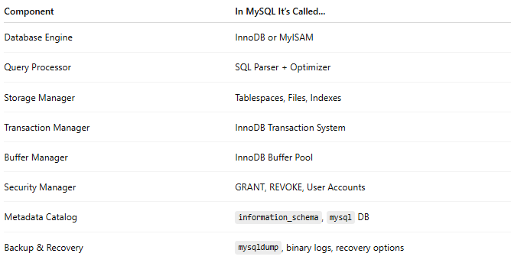
Component | In MySQL It’s Called...
Database Engine | InnoDB or MyISAM
Query Processor | SQL Parser + Optimizer
Storage Manager | Tablespaces, Files, Indexes
Transaction Manager | InnoDB Transaction System
Buffer Manager | InnoDB Buffer Pool
Security Manager | GRANT, REVOKE, User Accounts
Metadata Catalog | information_schema, mysql DB
Backup & Recovery | mysqldump, binary logs, recovery options

🧠 Why Understanding Components Matters
# Source: AI Source: Provided by: [Data Path: Persons Table -> ID Column: 1, Name_En Column: Motasem Essam] -> From: [ChatGPT] on [6/10/2026]
- Helps you optimize performance
- Aids in troubleshooting issues
- Useful when designing scalable and secure systems
- Critical for DBAs, architects, and developers

